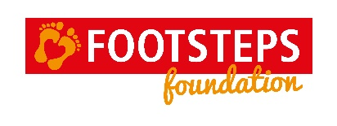

EQUIPMENT BANK REQUEST FORM
Footsteps Foundation funds 50% of the cost towards specialist equipment that is used and recommended by our therapists at Footsteps.
CHILD’S NAME: _____________________________________________________________________
PARENT’S NAME: ___________________________________________________________________
EQUIPMENT REQUEST
ITEM | SUPPLIER | TOTAL COST  (INC VAT & DELIVERY)
TOTAL COST OF ITEMS |  | £

Name of therapist(s) who has/have recommended the above equipment
__________________________________________________ Date ____________________
50% of total cost:

Please note, Footsteps Foundation can pay a maximum of £200 for each child over the course of a year (depending on available funds).

£

Checklist:
Footsteps Foundation cannot contribute towards the cost without an invoice or order confirmation.

Order invoices
Please provide your account details in order for Footsteps Foundation to transfer 50% of the cost to you.
Name of Account Holder ______________________________________________________
Account Number _________________________ Sort Code __________________________

Please send your completed request form along with your order invoices to Footsteps Foundation, 4 Queen Street, Dorchester-on-Thames, OX10 7HR or email to maggie@footstepsfoundation.com

